SustainableTogether – Flourishing Business Model Canvas Analysis
Proof of concept for the FBC–EA–SE integration framework (paper: Toward Net-Positive Systems) – June 2026

1. Purpose and context
This document records the business model analysis of SustainableTogether, an illustrative enterprise that transforms a conventional photovoltaic (PV) system sales business into a circular, lease-based product-as-a-service model. It is the first of three linked proof-of-concept artifacts:
- SustainableTogether_FBMC_Analysis.docx – business model design on the Flourishing Business Canvas (this file)
- SustainableTogether_Financial_Model.xlsx – early economic verification (cost, revenue, NPV/IRR)
- SustainableTogether_FFBB_Assessment.xlsx – socio-environmental verification against the 23 Future-Fit Break-Even Goals

Together they demonstrate the iterative early-verification loop of the framework: design the business model on the FBC, verify it economically and against science-based sustainability thresholds, adjust, and re-verify – before any enterprise architecture or systems engineering commitment is made.

2. The canvas
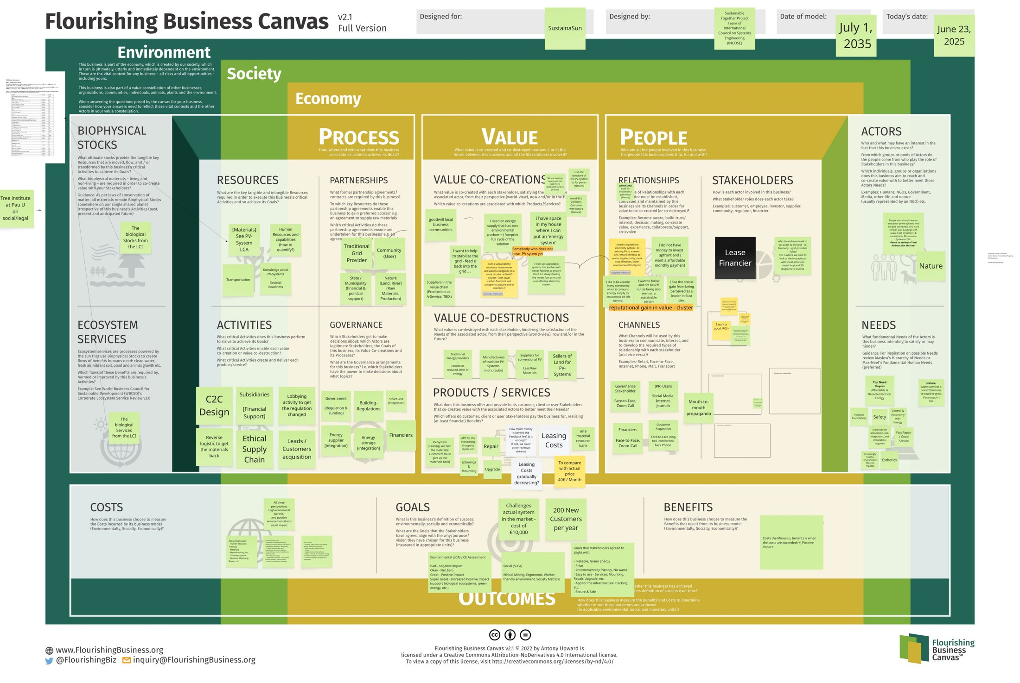
Figure 1. SustainableTogether Flourishing Business Canvas (workshop result, Flourishing Business Canvas v2.1 © A. Upward, CC BY-ND 4.0)

3. Canvas content – Iteration 1
Perspective / element | Iteration 1 content (initial concept)
Society – Actors / Stakeholders | Homeowners and community users, traditional grid providers, municipalities, financiers, suppliers; nature explicitly modeled as stakeholder
Society – Needs | Affordable and reliable green energy, safety, autonomy, ethics
Environment – Biophysical stocks | Materials from PV LCA: silicon, aluminium, scarce metals; land/river materials
Environment – Ecosystem services | Solar irradiation; biological stocks and services from the LCI
Economy – Value co-creations | Zero-/low-footprint energy supply; feed energy back to stabilize the grid; reputational gain
Economy – Value co-destructions | Reduced offer for traditional energy providers and manufacturers of non-circular PV systems
Economy – Activities | Leasing, installation, monitoring, repair; reverse logistics to recover materials; C2C design (planned)
Economy – Partnerships | Traditional grid provider, community users, state/municipality, suppliers in production-as-a-service value chain, financiers
Economy – Resources | PV systems and materials, human resources and capabilities, knowledge about PV systems
Economy – Channels | Face-to-face, Zoom, internet/social media, word-of-mouth; governance stakeholder contacts
Economy – Governance | Government (regulation and funding), building regulations, smart-grid integration rules, energy supplier and storage integration, financiers
Economy – Costs | Leasing costs (capital), O&M, customer acquisition (200 new customers/yr), subsidies/lobbying effort
Economy – Benefits | Reliable green energy, no waste, easy to use, secure and safe; 200 new customers per year
Economy – Goals | Net-zero to super-positive impact, measured by LCA/CE assessment; high economic, environmental and social benefit

4. Verification findings – Iteration 1
Economic verification (financial model): the one-to-one conversion of the sales business into a lease model fails. New-component CAPEX of 16,500 EUR per system against a lease of 119 EUR/month plus 60 EUR/yr feed-in revenue yields a margin of 1,083 EUR per system-year, a 15.2-year simple payback, an IRR of 0.3% and an NPV of −9.2 M EUR at 6% WACC over the 20-year fleet model.
Socio-environmental verification (FFBB): average fitness across the 23 Break-Even Goals is 74.8%, but two goals fall below 50% – BE04 (procurement: unassessed module supply chain) and BE19 (products cannot yet be repurposed: bonded mounting, storage not designed for disassembly) – and only one of five business-specific hotspot goals reaches 75%. The concept fails the interim acceptance gate.

5. Business model adjustments – Iteration 2
The two verification mechanisms drive coupled adjustments to the canvas. Notably, the sustainability-driven changes (refurbished module pool, demountable C2C design, longer service life) are also the main levers that repair the economics – illustrating eco-effectiveness rather than a cost trade-off.
FBC element | Iteration 2 adjustment | Driven by
Resources / Biophysical stocks | 30% refurbished module pool; recycled-aluminium mounting; wholesale procurement (CAPEX 16,500 → 12,500 EUR) | FFBB BE03/BE04; financial model (payback)
Products / Services | Cradle-to-cradle demountable design; service life extended 20 → 24 years; battery second-life partnership | FFBB BE19; financial model (margin per system)
Value co-creation | Storage aggregated into a virtual power plant: flexibility revenue 60 → 140 EUR/system/yr | Financial model; FBC goal "stabilize the grid"
Costs / Benefits | Lease repositioned 119 → 149 EUR/month including full service guarantee; transparent, LCA-substantiated communication | Financial model; FFBB BE15
Activities / Partnerships | Take-back anchored contractually in lease; supplier code of conduct with third-party audits; living-wage clause for subcontractors | FFBB BE04/BE11/BE17
Activities (operations) | Electric service vans, renewable PPA, reusable packaging loop (sustainability opex +90 EUR/system/yr) | FFBB BE01/BE06/BE07
Governance / Resources | Cash moved to sustainability-focused bank; advocacy positions disclosed | FFBB BE22/BE23
Channels | Community channel and word-of-mouth prioritized (CAC 600 → 400 EUR) | Financial model

6. Verification results after Iteration 2
Indicator | Iteration 1 | Iteration 2
NPV @ 6% WACC (20-yr fleet model) | −9.2 M EUR | +2.4 M EUR
IRR | 0.3% | 7.6%
Margin per system | 1,083 EUR/yr | 1,458 EUR/yr
Simple payback per system | 15.2 years | 8.6 years
FFBB average fitness (23 Break-Even Goals) | 74.8% | 87.8%
FFBB goals below 50% fitness | 2 (BE04, BE19) | 0
Hotspot goals ≥ 75% (BE01/04/06/18/19) | 1 of 5 | 5 of 5
Verdict | FAIL – revise business model | PASS – proceed to EA/SE transformation

Both verifications pass: the adjusted business model is economically viable (NPV +2.4 M EUR, IRR 7.6% > 6% WACC) and clears the Future-Fit interim gate (no goal below 50%, average fitness 87.8%, all hotspot goals ≥ 75%). The concept is released for translation into enterprise architecture and systems engineering via the traceability map (Table 1 of the paper).

7. Handover to EA and SE
Key items that flow into the EA/SE mapping: the take-back obligation and demountability become system requirements and operational scenarios (end-of-lease take-back); virtual-power-plant aggregation becomes a smart-grid integration capability with interface requirements toward the grid operator; the FFBB hotspot goals become verifiable sustainability constraints carried through requirements and V&V; supplier audit and living-wage clauses become procurement and governance constraints.

8. Assumptions and limitations
All figures are illustrative, plausibility-checked estimates for the German residential PV market (2026); FFBB scores are expert estimates following the Benchmark’s progress-indicator approach (0–100%). The official Benchmark defines break-even as 100% fitness on every goal; the gate used here is an interim design checkpoint. The example is intended as a proof of concept for the method, not as a market study.

